Welcome to Ridge-I assignment. This task aims to evaluate your technical skills in managing a neural network design and dataflow for a classification task. It evaluates your code readability, performance and convergence given some data constraints, and your ability to summarize and explain your results.

**Introduction:**

We want you to design a network that combines supervised and unsupervised architectures in one model to achieve a classification task.

**Architecture:**

The model must start with autoencoder(s) (stacking autoencoder is ok) that is connected through its hidden layer to another network of your choice, as shown in the figure below:

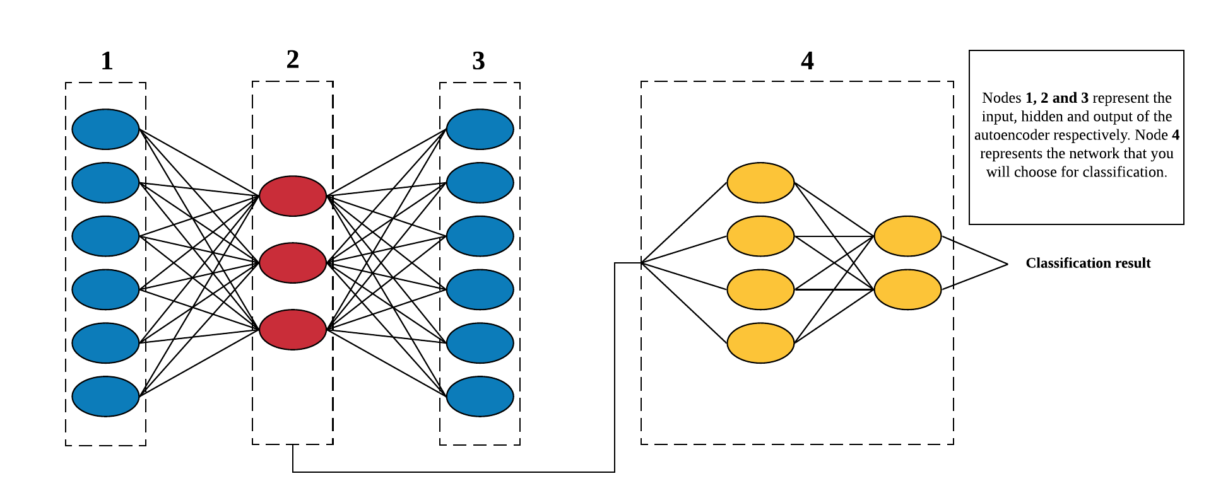

This autoencoder takes an input (image) at node 1 and reconstructs it at its output at node 3. It creates valuable features at its hidden layers (node 2) during this process. it is hypothesized that if node 2 is used as input for the CNN (node 4) then the classification can be improved.

**Data:**

We want to use this model to classify Cifar-10 dataset under the condition that the you can use 50% of the following classes for training (bird, deer and truck) while you can use any percentage you think is appropriate for the other classes.

**Training:**

You are free to propose the best number of epochs, mini batch size, optimizer and regularizing technique and data augmentation that you think is suitable for this scenario. You have the choice of training the autoencoder separately or in an end to end style with the classifier. Be creative.

**Deliverables:**

We wish to receive your code in any convenient sharing from (GitHub, Collab, Jupiter or docker) plus a detailed report analyzing the model, its contribution and a discussion of your findings.